# Exercise 2

Run the status command. Notice how it tells you what branch you are in

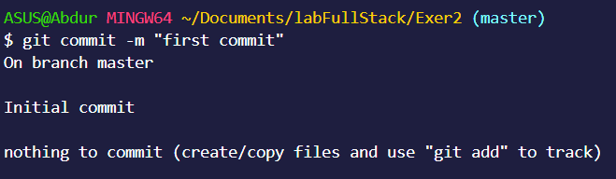

Use the branch command to create a new branch.

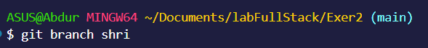

Use the checkout command to switch to it.

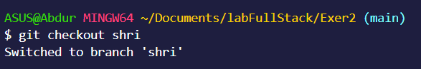

Make a couple of commits in the branch – perhaps adding a new file and/or editing existing ones.

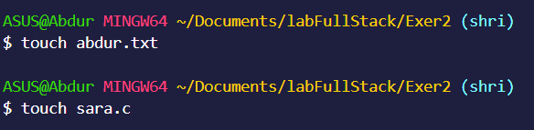

Use the log command to see the latest commits. The two you just made should be at the top of the list

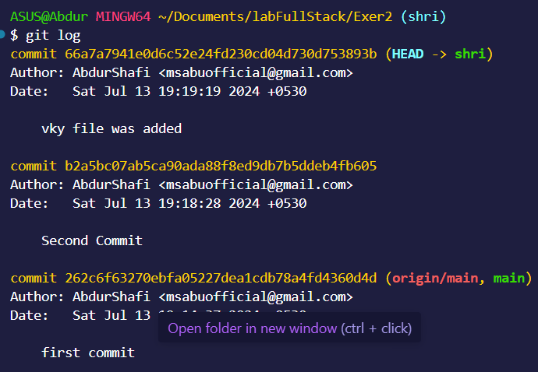

Use the checkout command to switch back to your branch.

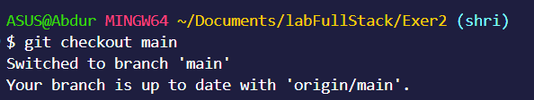

Use gitk to take a look at the commit graph; notice it’s linear.

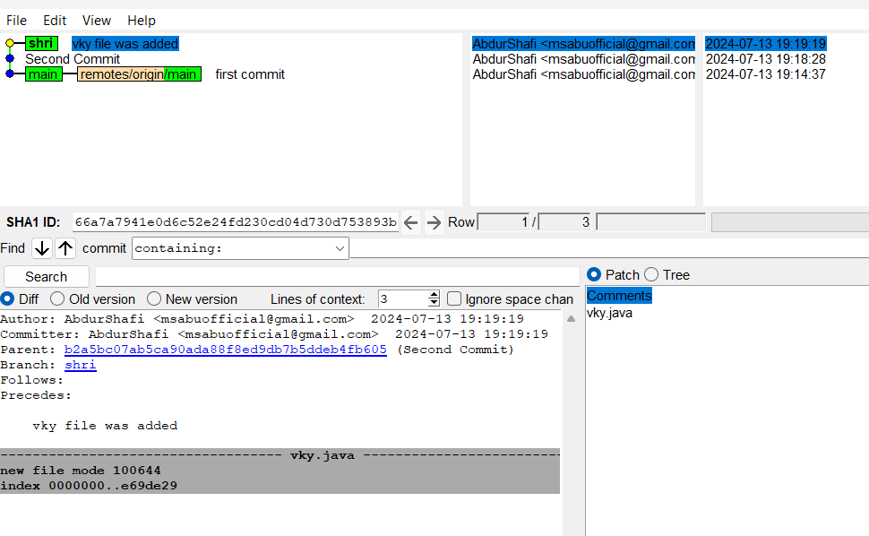

Now checkout the master branch again

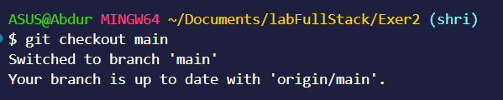

Use the merge command to merge your branch in to it. Look for information about it having been a fast-forward merge

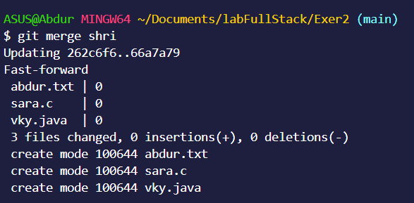

Look at git log, and see that there is no merge commit.

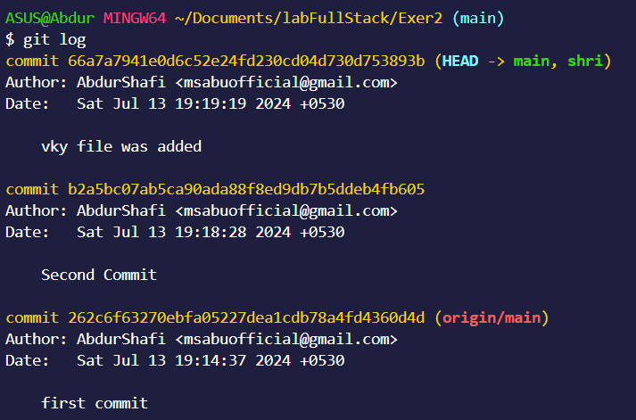

Take a look in gitk and see how the DAG is linear

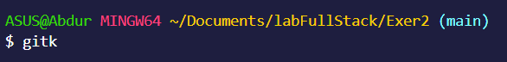

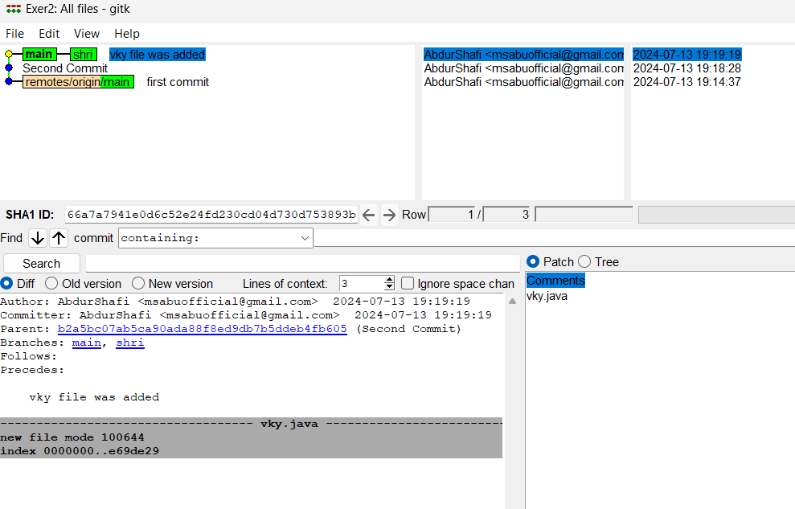

Switch back to your branch

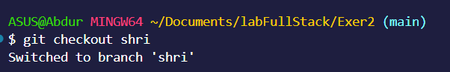

Make a couple more commits

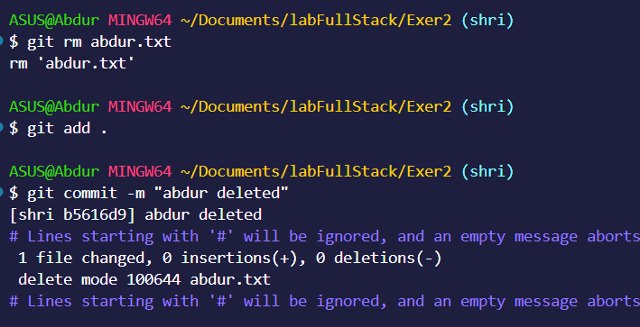

Switch back to master

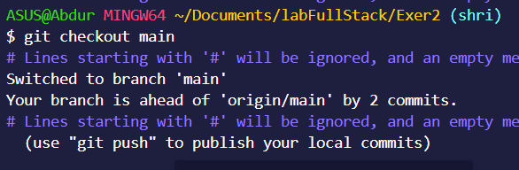

Make a commit there, which should edit a different file from the ones you touched in your branch

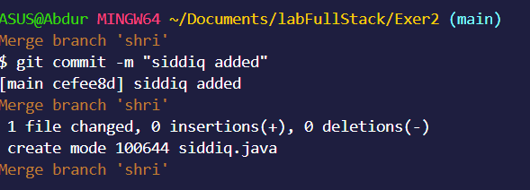

Now merge your branch again

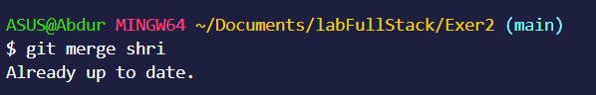

Look at git log

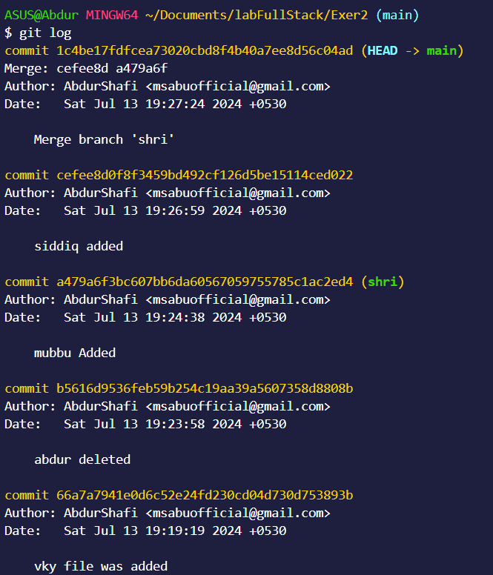

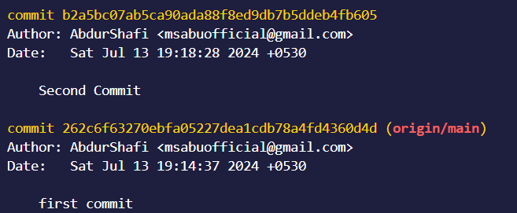

Also look in gitk

